Vision System

## Report by Tianchen Yang

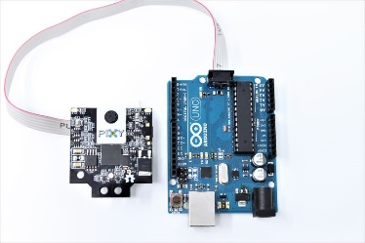 Vision system is one of the most important components of the droid. The soccer robot is built on the purpose of detecting the ball, chasing the moving ball and pushing the ball to the opponent's goal to win the competition, and vision systems enable the droid ability to see and find the target in a complicated environment. Without the assistant of the vision system, the robot only can move aimlessly. The vision system can be defined as using the camera to generate, identify process the data massage of the ball movement, and then transfer the newest data to the microcontroller, finally, the initial data will be decrypted and translated to assembly language which can be Identified by the microcontroller system.

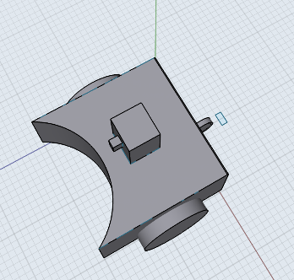Our team decided to use the morph chart method as the general concept method because the 6-3-5 method and sketch method are not suitable in this case because only two of the six team members have the experience with computing and vision system, which means majority of the team members cannot provide useful advise. Also, the difference between each microcontroller or camera are just some property, such as how many pins or input interface, or the different power supply, different API to connect with, But this has difficulty shown in the sketches, which means the sketch method should be removed too. The morph chart can clearly show the advantage and disadvantage for each selection, and is quite convenience to add, delete or change the initial selection.

After listing the morph chart, we begin to select some of the options according to the budget and ability we have. For instance, the pixy2 camera and the Arduino microcontroller are provided by the UNSW and doesn't count in the budget, which will save nearly 80 to 120 AU dollars. So the camera and microcontroller are easily chosen. Also, when the microcontroller is decided, the programming language is also decided, which is the C, etc.

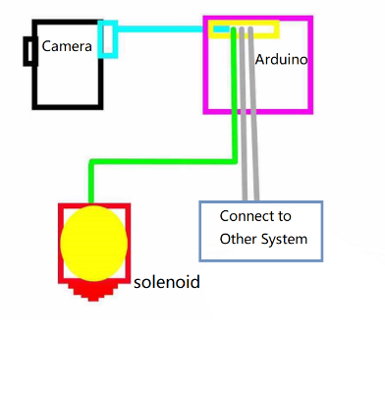

In this procedure of the Vision System sketches, we can easily understand the vision system. Firstly, the camera will detect the ball automatically and transfer the encrypted data to the Arduino processor, such as providing the ball position when found the ball or give orders to change the position when losing the target. Then, the microcontrollers will process the data used the programming, and determine the current status to select the next step(instruction). For example, when the ball is at the launcher position, the camera will identify it and send “pushing” instruction to the Arduino, and once the processor received the “pushing” signal, it will set the solenoid pin to high, and assist the solenoid to push the ball precisely and immediately.

Group 20

Tianchen Yang Z5248280

Reference

The Arduino image is from:

https://www.google.com/url?sa=i&source=images&cd=&ved=2ahUKEwi07vCIoKLlAhWVfisKHTC_A94QjRx6BAgBEAQ&url=https%3A%2F%2Fpixycam.com%2Fpixy2%2F&psig=AOvVaw1CWx95ZZY2ULnudsxQ6KDj&ust=1571365831199242